**TODO List**

**Largest object can be scanned**

Scanning: Diameter: 22.5cm. Max. Height: 17.5cm.

**Time to scan an object - does it differ or same for any object**

The scanning time is same for any object. It is only a function of imaging detail accuracy.

Time to scan: 12m30s

Dots formed: 116257

Surface Area of Box: A (6.3cm, 8.5cm, 11.9cm) - 6.3cm x 8.5cm

Height 11.9

6.3x8.5+2*(11.9x6.3+11.9x8.5)=405.79

286

**Precision of scan - dots per cm^2**

**=** Dots formed / Surface Area of Box.

Hardware:

* Calibration Data

* Step Size Steps per Revolution

* 40 160

Dimensions: Depth: 28.8cm; Height: 35.8cm; Width: 49.0cm.

Weight: 1.34kg.

Pictures:

USB cables - I might have 1 but send one just in case?

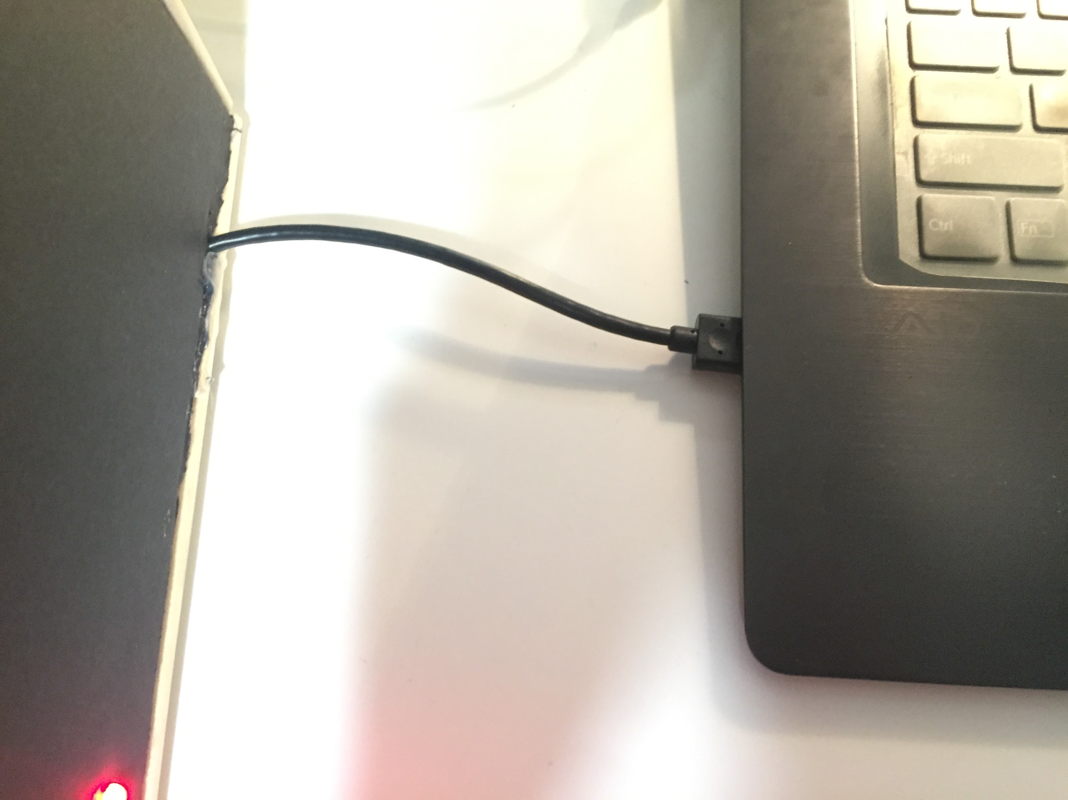

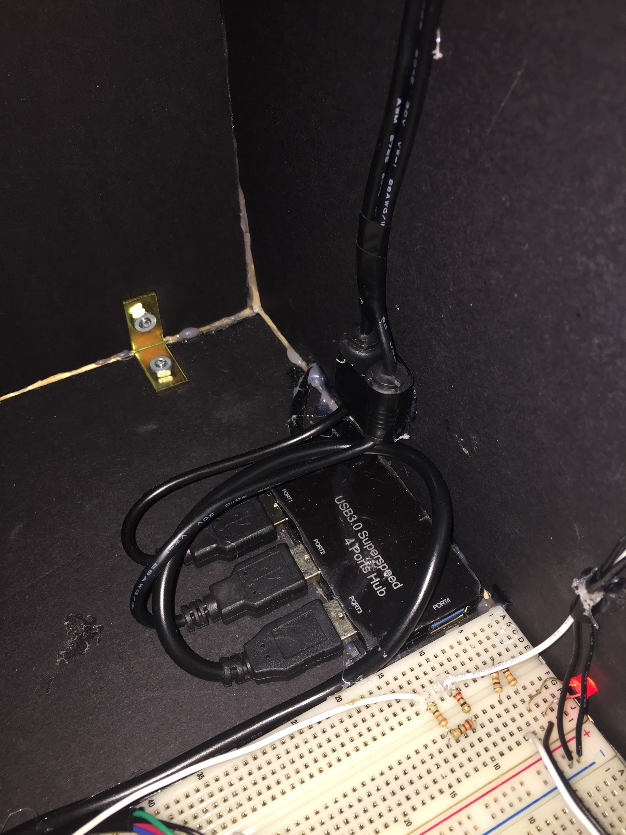

Scanner connected to laptop - basically scan in progress

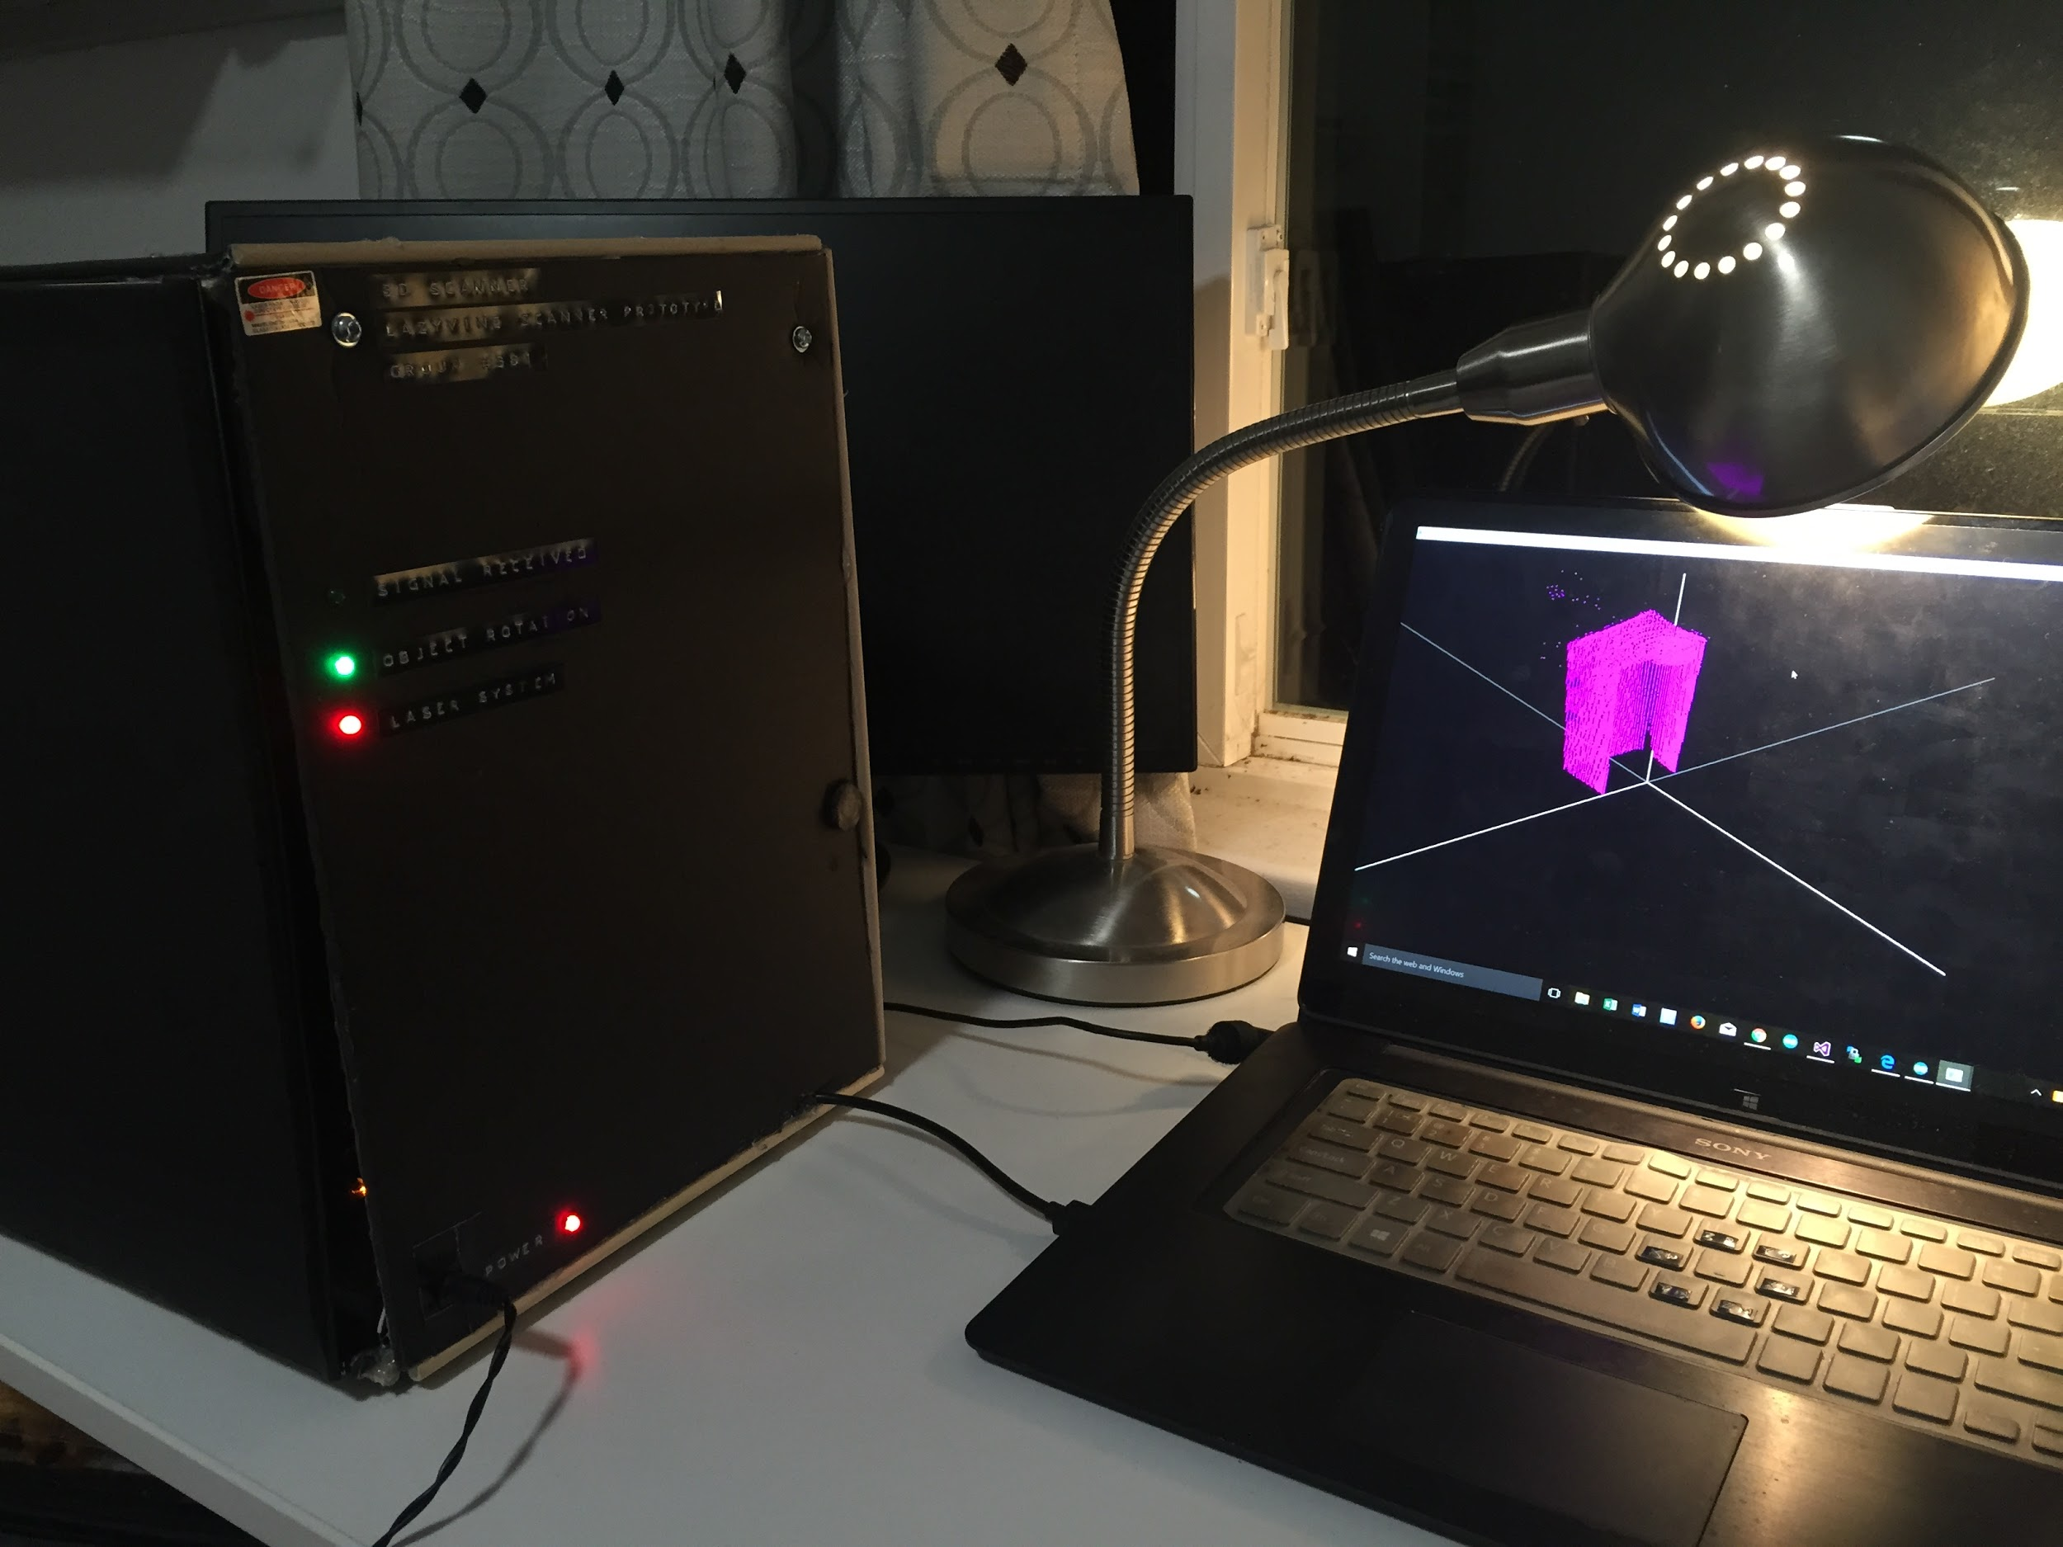

Mug sitting on the plate

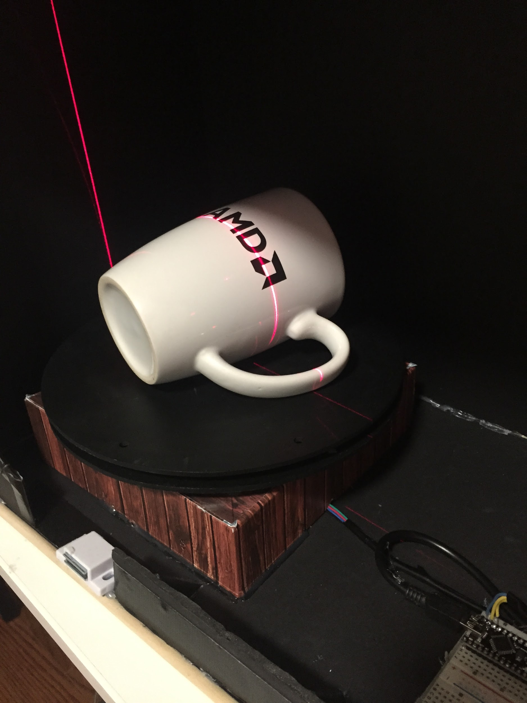

Point cloud - normal, rotate, zoom

normal

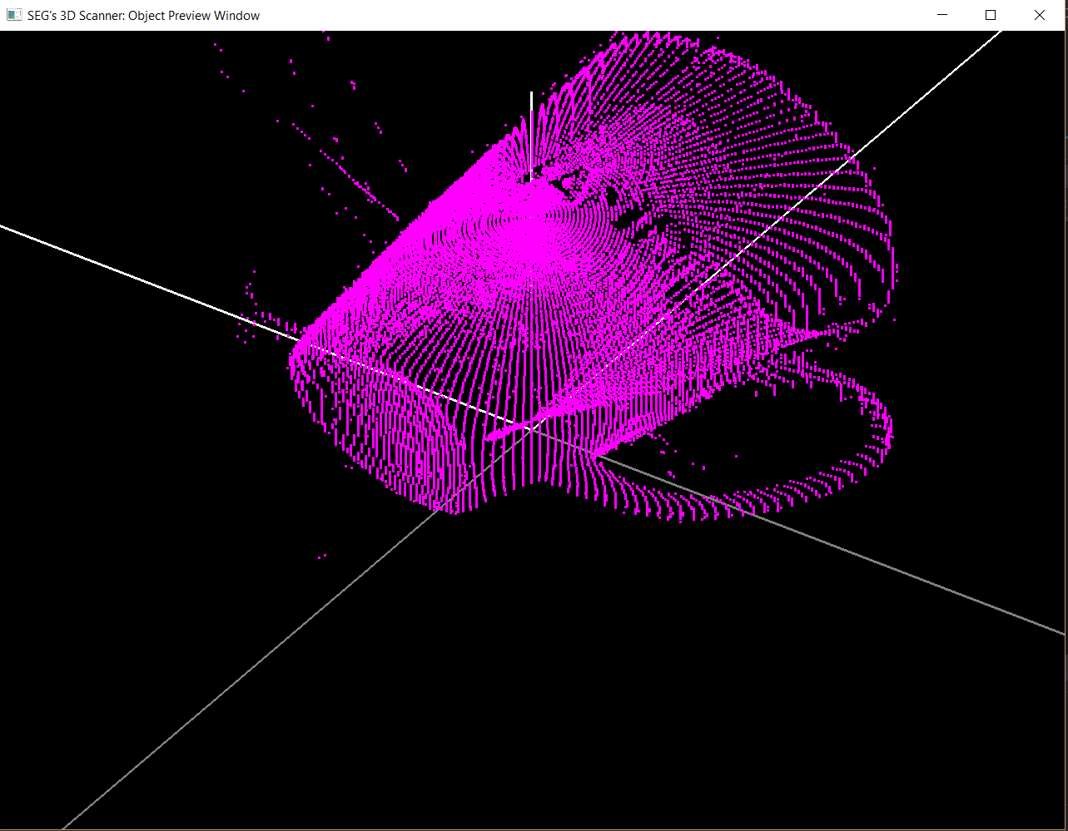

rotated

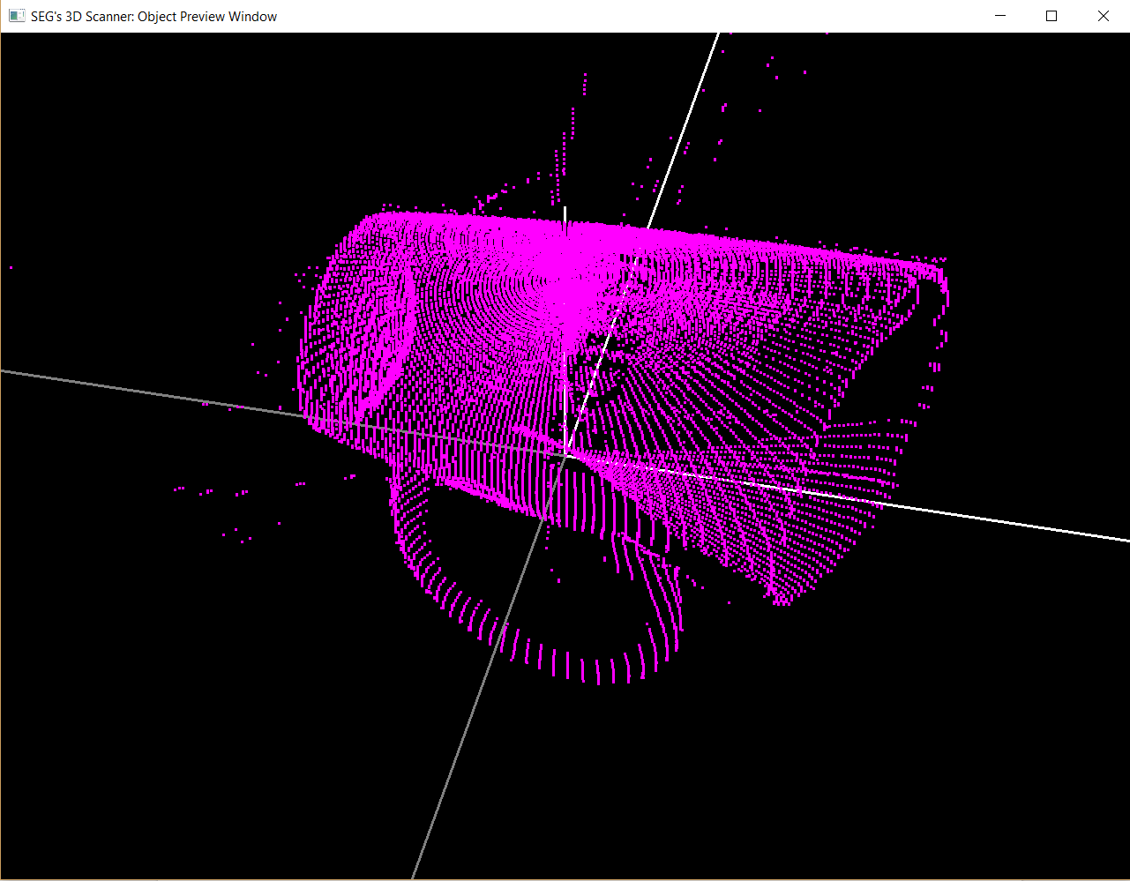

Zoomed out

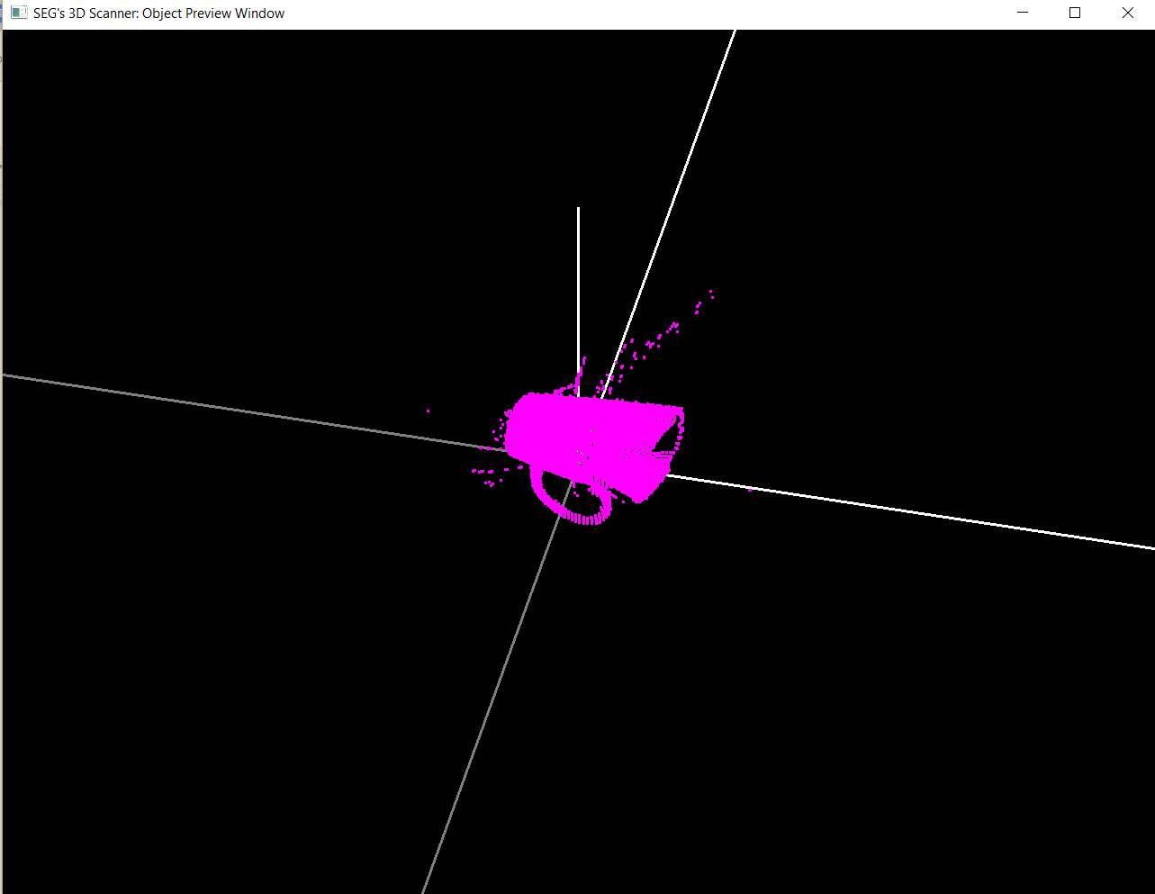

Zoomed into

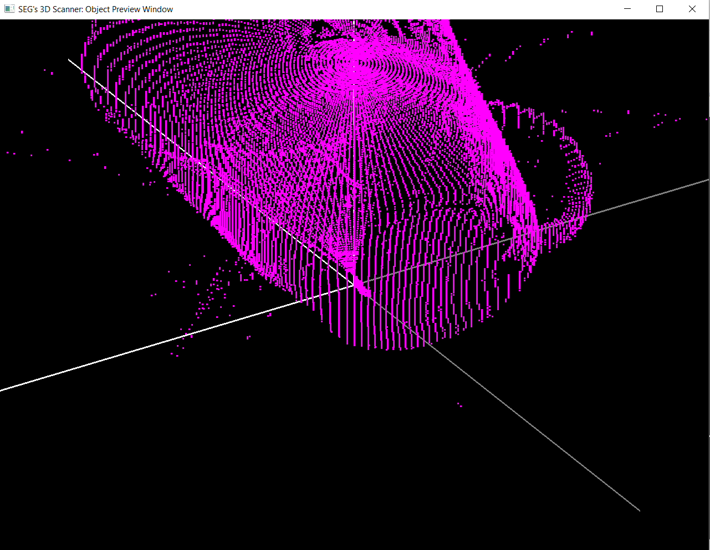

Zoomed into so much that its like ur eyeballs are inside that cup, you can only see half of the cup.

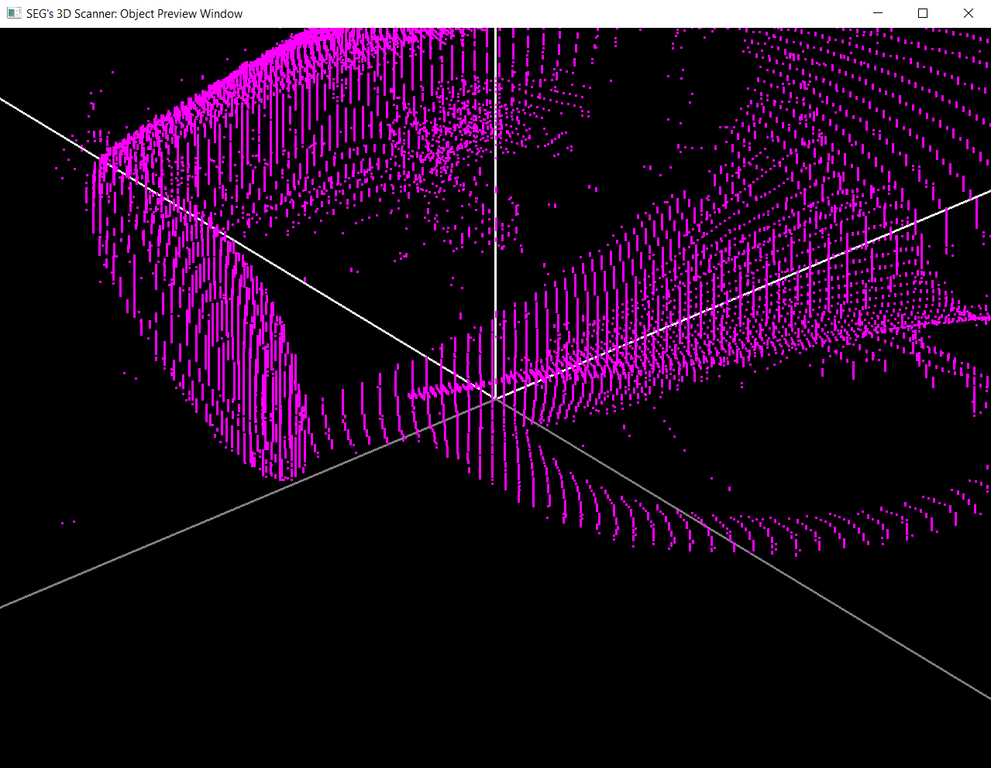

Scanning an object of 22.5 diameter and 17.5 height (or one for each limit)

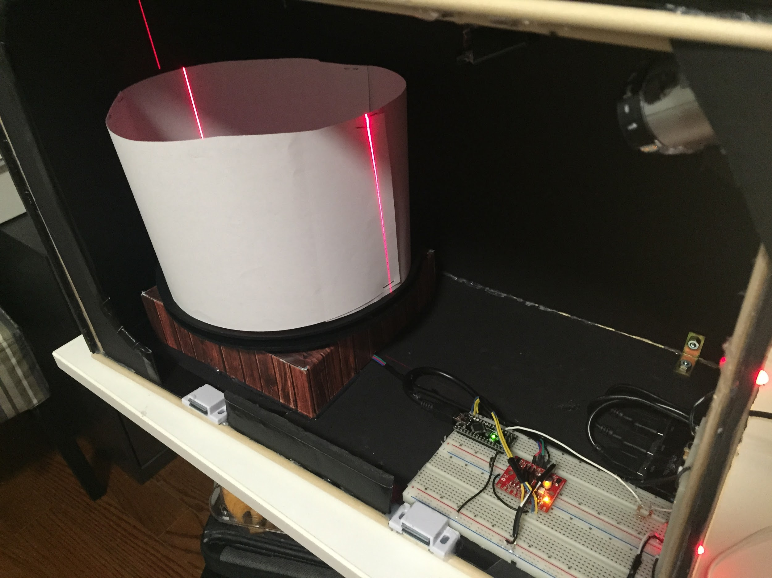

Extras.

